DEPT. OF ELECTRICAL & ELECTRONICS ENGINEERING

SRM INSTITUTE OF SCIENCE AND TECHNOLOGY, Kattankulathur – 603 203

|  |  |  |
| --- | --- | --- |
| Title of Experiment | : | **1. Verification of Kirchhoff’s Laws** |
| Name of the candidate | :DEBARGHYA BARIK | |
| Register Number | :RA2011026010022 | |
| Date of Experiment | :12.10.2020 | |

|  |  |  |  |
| --- | --- | --- | --- |
| Sl.  No. | Marks Split up | Maximum marks (50) | Marks obtained |
| 1 | Pre Lab questions | 5 |  |
| 2 | Preparation of observation | 15 |  |
| 3 | Execution of experiment | 15 |  |
| 4 | Calculation / Evaluation of Result | 10 |  |
| 5 | Post Lab questions | 5 |  |
| **Total** | | **50** |  |

Staff Signature

# PRE LAB QUESTIONS

1. **Define Ohm’s law.**

Ohm’s Law states that the voltage or potential difference between two points is directly proportional to the electric current passing through the circuit joining the two points. The mathematical expression: V = I x R [where, V = potential difference between two points

I = current through the circuit

R = resistance of the circuit]

1. **State KCL and KVL.**

Kirchhoff’s Current Law or KCL states that, in a closed circuit, the sum of all currents entering into the node is equal to the sum of all currents leaving the node i.e. the algebraic sum of currents in a network of conductors meeting at a point is zero.

Kirchhoff’s Voltage Law or KVL states that, the algebraic sum of voltage at node in a closed circuit is equal to zero

1. **Define absolute potential and potential difference**

Absolute Potential is the electrical condition, that determines the flow of charge from one conductor to other in contact, in an electric potential.

Potential Difference is between two points in an electric circuit is defined as the work done in moving a unit positive charge from one point to the other point.

1. **What is the difference between mesh and loop?**

|  |  |
| --- | --- |
| **Loop** | **Mesh** |
| A loop is a closed path in a circuit where the two nodes are not traversed twice except the initial point, which is also the final one. In a loop other paths can be included inside.  It can or cannot be further divided into closed paths. | Mesh: A mesh is a closed path in a circuit with no other paths inside. In other words, a mesh is a loop with no other loops inside.  It is a closed path which can’t be divided into closed paths. |

1. **What is super-node?**

In circuit theory, a super-node is a theoretical construct that can be used to solve a circuit. This is done by viewing a voltage source on a wire as a point source voltage in relation to other point voltages located at various nodes in the circuit, relative to a ground node assigned zero or negative charge.

**VERIFICATION OF KIRCHOFF’S LAWS**

**Aim:**

**Experiment No. 1 Date :**

To verify Kirchhoff’s current law and Kirchhoff’s voltage law for the given circuit.

# Apparatus Required:

|  |  |  |  |
| --- | --- | --- | --- |
| Sl.No  . | Apparatus | Range | Quantity |
| 1 | RPS (regulated power supply) | (0-30V) | 2 |
| 2 | Resistance | 330, 220 1k | 6 |
| 3 | Ammeter | (0-30mA)MC | 3 |
| 4 | Voltmeter | (0-30V)MC | 3 |
| 5 | Bread Board & Wires | -- | Required |

**Statement:**

**KCL:** The algebraic sum of the currents meeting at a node/junction is equal to zero.

**KVL:** In any closed path / mesh, the algebraic sum of all the voltages is zero.

# Precautions:

* 1. Voltage control knob should be kept at minimum position.
  2. Current control knob of RPS should be kept at maximum position.

# Procedure for KCL:

1. Give the connections as per the circuit diagram.
2. Set a particular value in RPS.
3. Note down the corresponding ammeter reading
4. Repeat the same for different voltages

# Procedure for KVL:

1. Give the connections as per the circuit diagram.
2. Set a particular value in RPS.
3. Note all the voltage reading
4. Repeat the same for different voltages

# HARDWARE SETUP:

**C ircuit for KCL verification:**

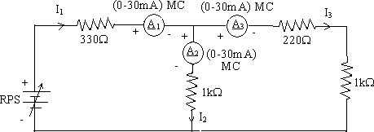

**C ircuit for KVL verification:**

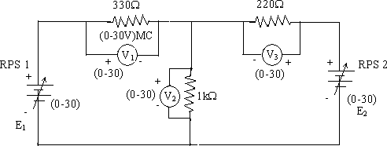

**KCL - Theoretical Values:**

|  |  |  |  |  |  |
| --- | --- | --- | --- | --- | --- |
| Sl.  No. | Voltage E | Current | | | I1 = I2 + I3 |
| I1 | I2 | I3 |
| Volts | mA | mA | mA | mA |
| 1 | 5 | 5.68 | 3.12 | 2.56 | 5.68 |
| 2 | 10 | 11.37 | 6.25 | 5.12 | 11.37 |
| 3 | 15 | 17.05 | 9.37 | 7.68 | 17.05 |
| 4 | 20 | 22.74 | 12.50 | 10.24 | 22.74 |
| 5 | 25 | 28.42 | 15.62 | 12.80 | 28.42 |

**KCL - Practical Values:**

|  |  |  |  |  |  |
| --- | --- | --- | --- | --- | --- |
| Sl.  No. | Voltage E | Current | | | I1 = I2 + I3 |
| I1 | I2 | I3 |
| Volts | mA | mA | mA | mA |
| 1 | 5 | 5.68 | 3.12 | 2.56 | 5.68 |
| 2 | 15 | 17.05 | 9.37 | 7.68 | 17.05 |
| 3 | 25 | 28.42 | 15.62 | 12.80 | 28.42 |

**KVL – Theoretical Values**

|  |  |  |  |  |  |  |
| --- | --- | --- | --- | --- | --- | --- |
| Sl.No  . | RPS | | Voltage | | | KVL  E1 = V1 + V2 |
| E1 | E2 | V1 | V2 | V3 |
| V | V | V | V | V | V |
| 1 | 10 | 10 | 1.17 | 8.83 | 1.17 | 10 |
| 2 | 15 | 10 | 4.40 | 10.6 | 0.6 | 15 |
| 3 | 20 | 10 | 7.63 | 12.37 | 2.37 | 20 |
| 4 | 20 | 15 | 4.98 | 15.02 | 17.67 | 20 |
| 5 | 20 | 20 | 2.33 | 17.67 | 2.33 | 20 |

**KVL - Practical Values**

|  |  |  |  |  |  |  |
| --- | --- | --- | --- | --- | --- | --- |
| Sl.No  . | RPS | | Voltage | | | KVL  E1 = V1 + V2 |
| E1 | E2 | V1 | V2 | V3 |
| V | V | V | V | V | V |
| 1 | 15 | 10 | 4.40 | 10.6 | 0.6 | 15 |
| 2 | 20 | 10 | 7.63 | 12.37 | 2.37 | 20 |
| 3 | 20 | 15 | 4.98 | 15.02 | 17.67 | 20 |

**Model Calculations:**

**KCL Circuit Stimulation:**

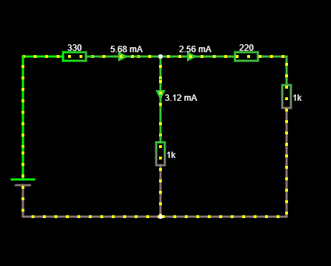

**KVL Circuit Stimulation:**

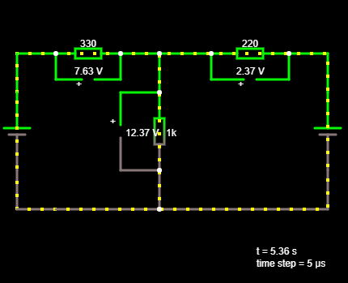

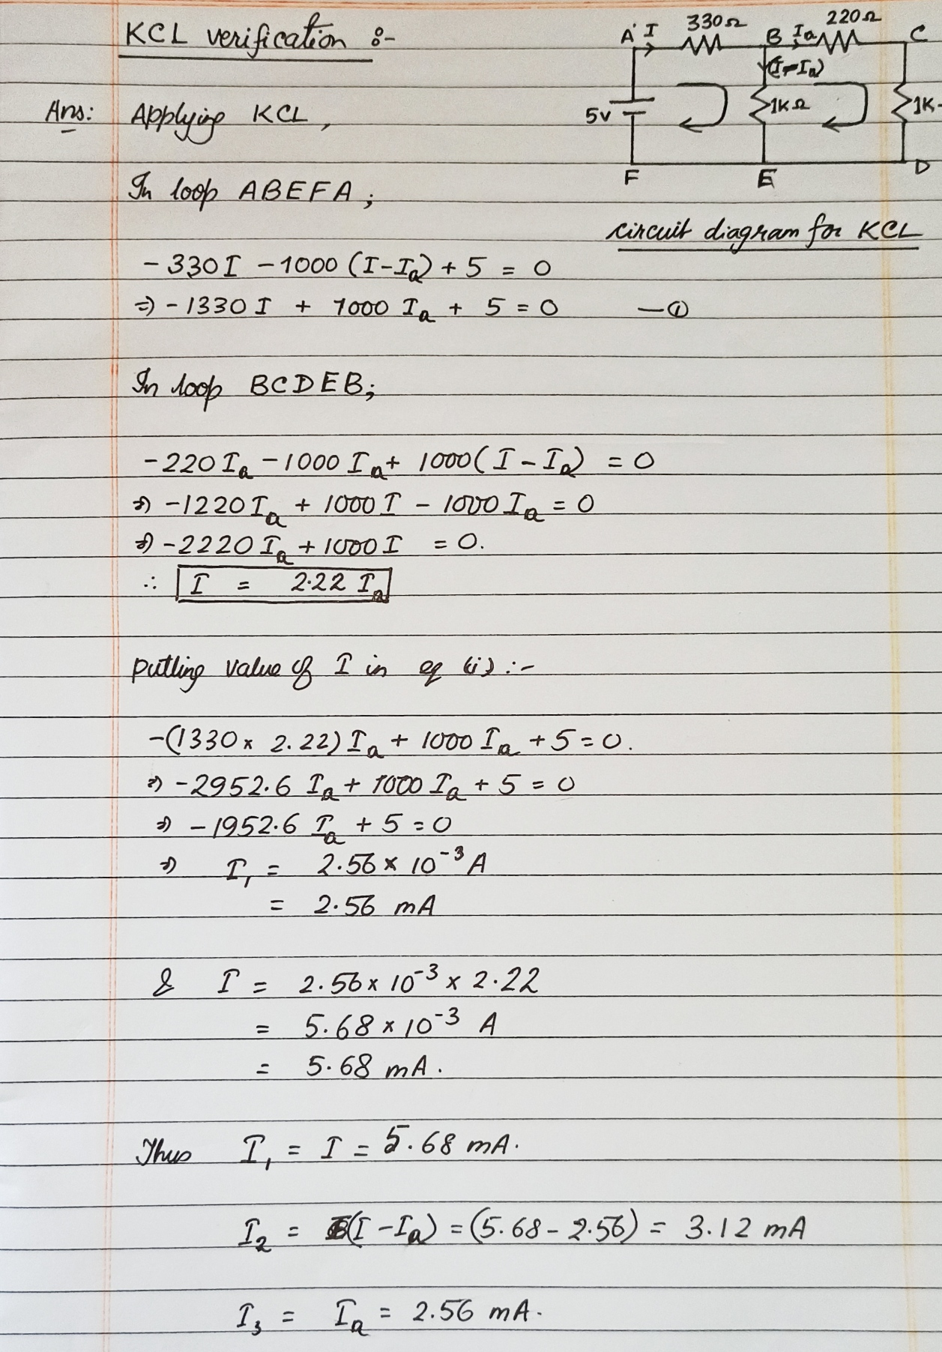

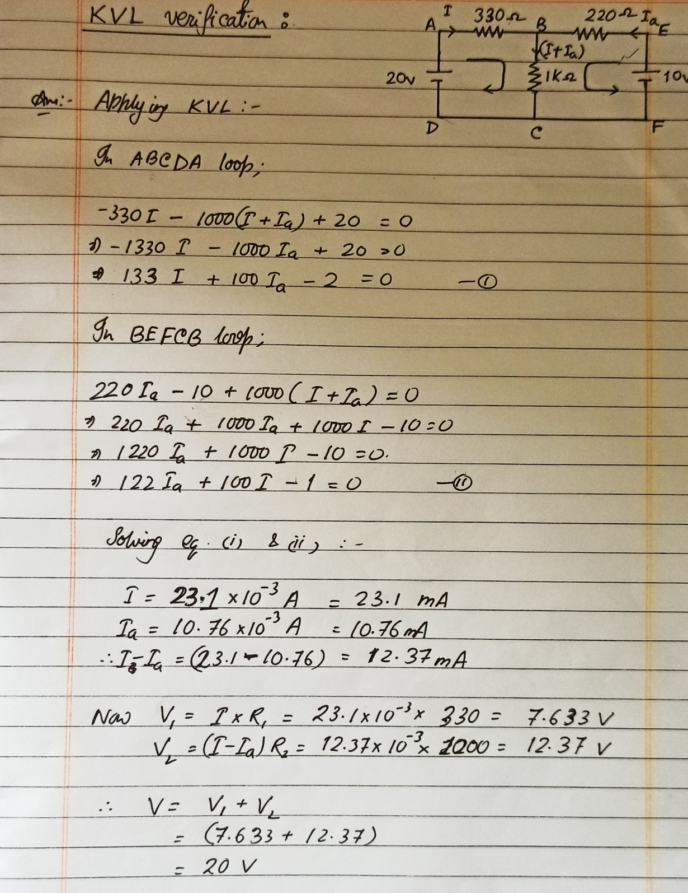

**Result:** The observations of current and voltage drop across the circuits of both KCL and KVL respectively that we get through the stimulator circuits are verified by theoretical calculations. Thus, Kirchhoff’s laws are verified and the aim of this laboratory experiment is satisfied.

**POST LAB QUESTIONS**

1. **Illustrate KCL and KVL.**

**KCL: Kirchhoff’s Current Law** is Kirchhoff’s first Law that states that the algebraic sum of all currents entering and leaving the circuit is equal to zero. This law deals with the Law of Conservation of Energy.  If the net charge in a region is constant, the current law will hold on the boundaries of the region. This means that the current law relies on the fact that the net charge in the wires and components is constant. Mathematically; 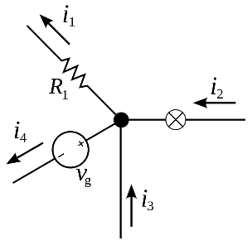i1 + i4 = i2 + i3

**KVL:** **Kirchhoff’s Voltage Law** is Kirchhoff’s second Law that states that “In any closed loop network, the total voltage around the loop is equal to the sum of all voltage drops within the same loop.” which is also equal to zero. In general form it states that the sum of all voltages within a loop is zero.

1. **Express the limitations of Ohm’s law?**

Limitations of this law:

* Now, this law is valid for conductors only and that too at a constant temperature. The resistance of a conductor increases with temperature. Hence, for changing temperature the V-I graph for a conductor will be non-linear (not a straight line).
* Ohm’s law is not followed by semiconductors. The V-I graph has a steep rising at a particular voltage, which indicates that the material begins to conduct properly only after a certain voltage.

1. **What is the practical application of Kirchhoff’s law?**

The practical applications of KCL and KVL are as follows

* Kirchhoff Voltage Law (**KVL**) and Kirchhoff Current Law (**KCL**) are two of the common laws that form the basis of electronics design.
* Kirchhoff's laws are used to measure the unknown standards such as current (I), Voltage (V), also the direction of moving current in the circuit.
* This rule is applicable to every circuit but it is very fruitful to solve complicated circuitries.

1. **Compare series and parallel circuits**

|  |  |
| --- | --- |
| **Series Circuit(s)** | **Parallel Circuit(s)** |
| In this circuit, all components are connected end-to-end, forming a single path for current flow.  The sum of voltages consumed by each resistance is equal to the voltage source. | In this circuit, all components are connected across each other; forming exactly two sets of electrically common points.  The voltages across each of the components is same, and the total current is equal to the sum of currents flowing through each component. |

1. **What is the difference between series and parallel connection of batteries?**

|  |  |
| --- | --- |
| **Series connection of batteries** | **Parallel connection of batteries** |
| Connecting batteries in series increases voltage, but does not increase overall amp-hour capacity. | Connecting batteries in parallel increases total current capacity by decreasing total resistance, and it also increases overall amp-hour capacity. |